**Registration Process for Foreign Experts at the 2024 World Life Science Conference**

1. **Visit the official website**
2. Go to the official website of the 2024 World Life Sciences Conference：<https://2024.wlsc.org.cn>

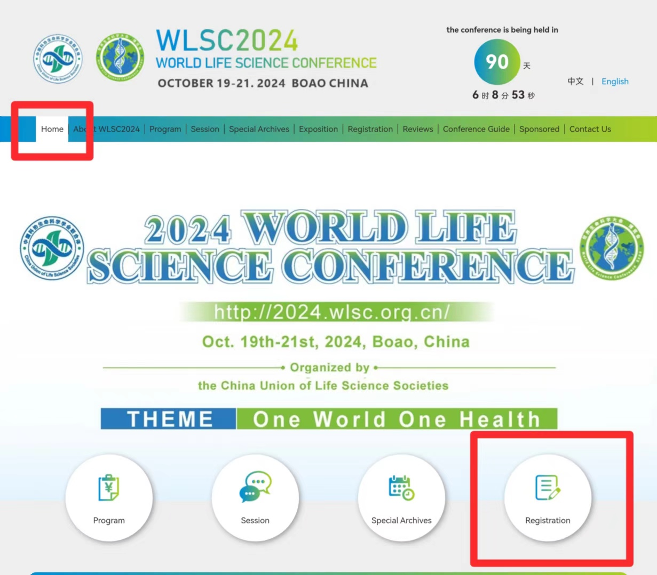

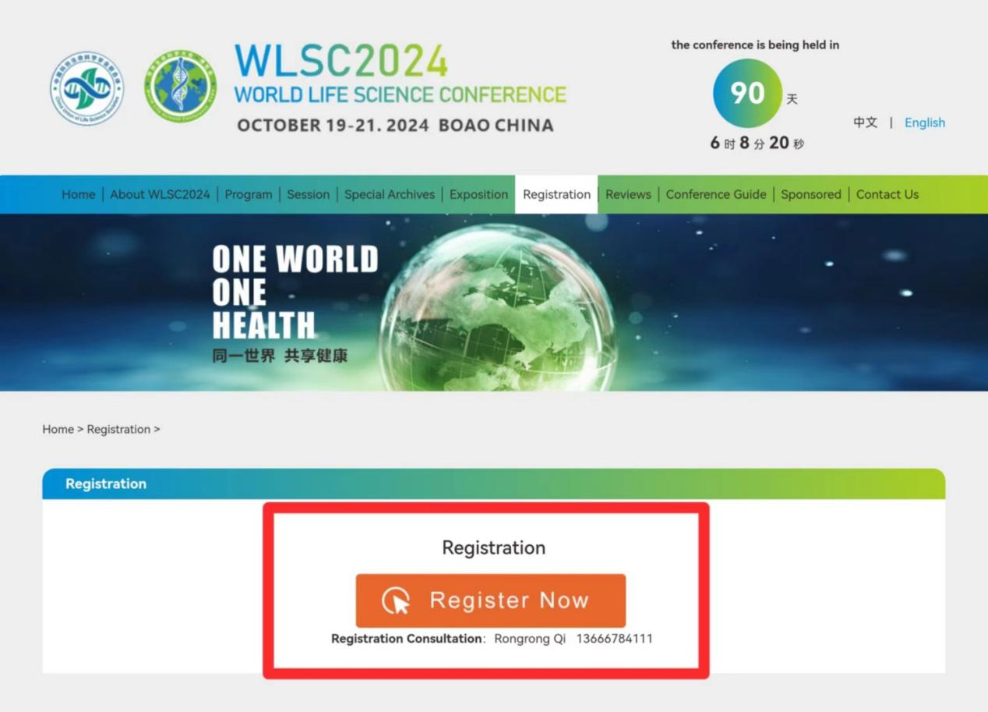

1. Click on "Registration" to open a new page.
2. Find the entry for foreign experts.
3. **Registration**

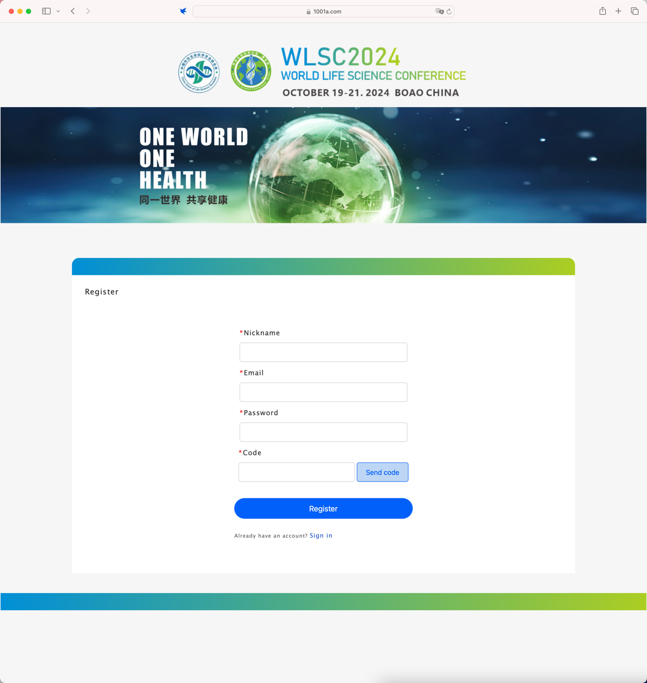

1. Sign up with your email address, enter the correct email address and you will receive a verification code. Fill in the verification code to complete the registration.

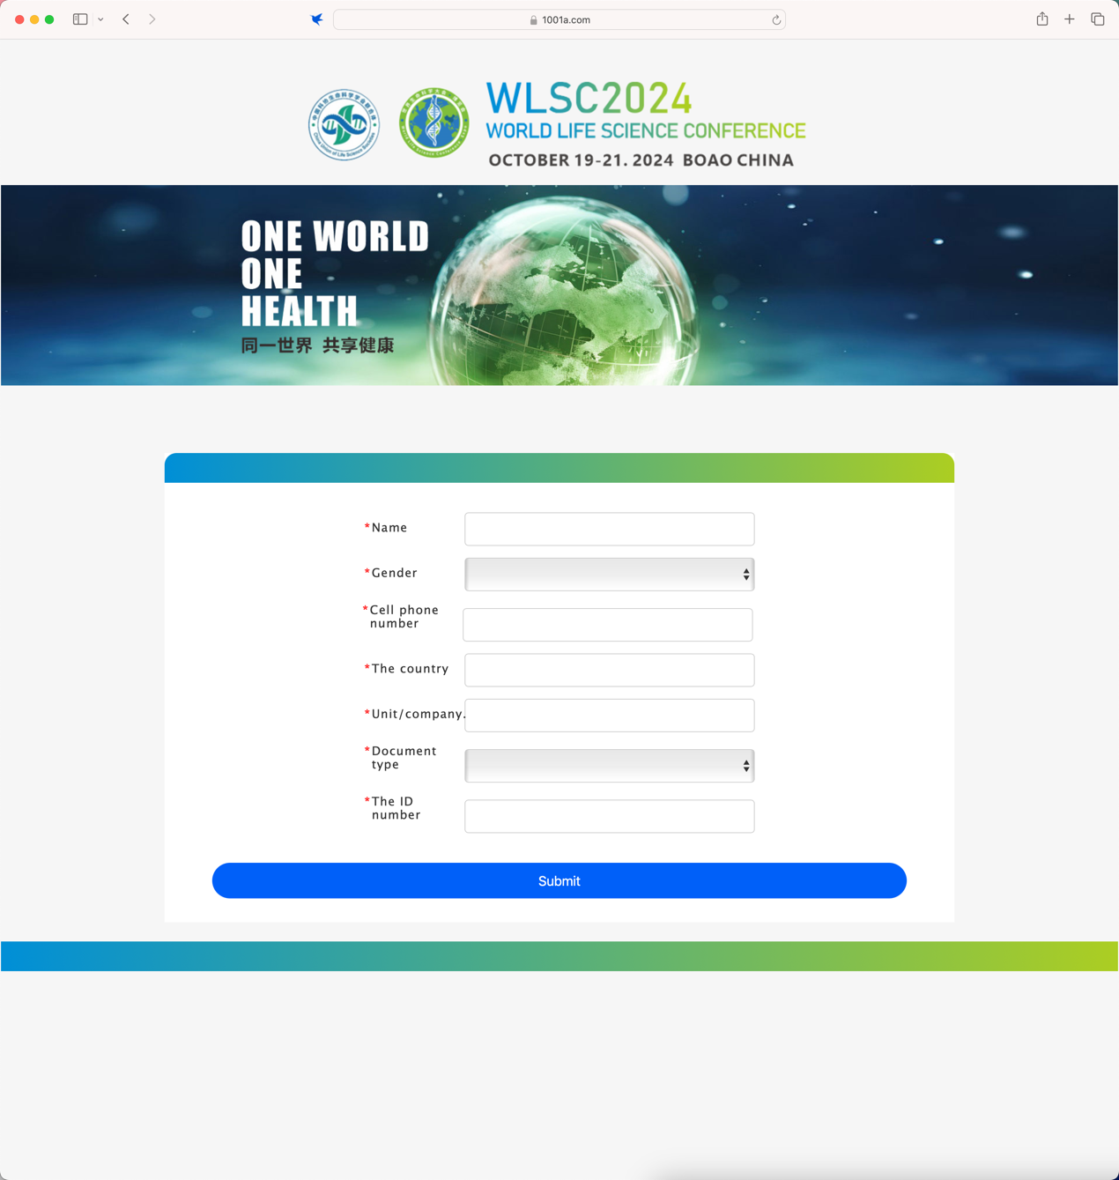

1. Fill in the information of the participating foreign experts and complete the registration.

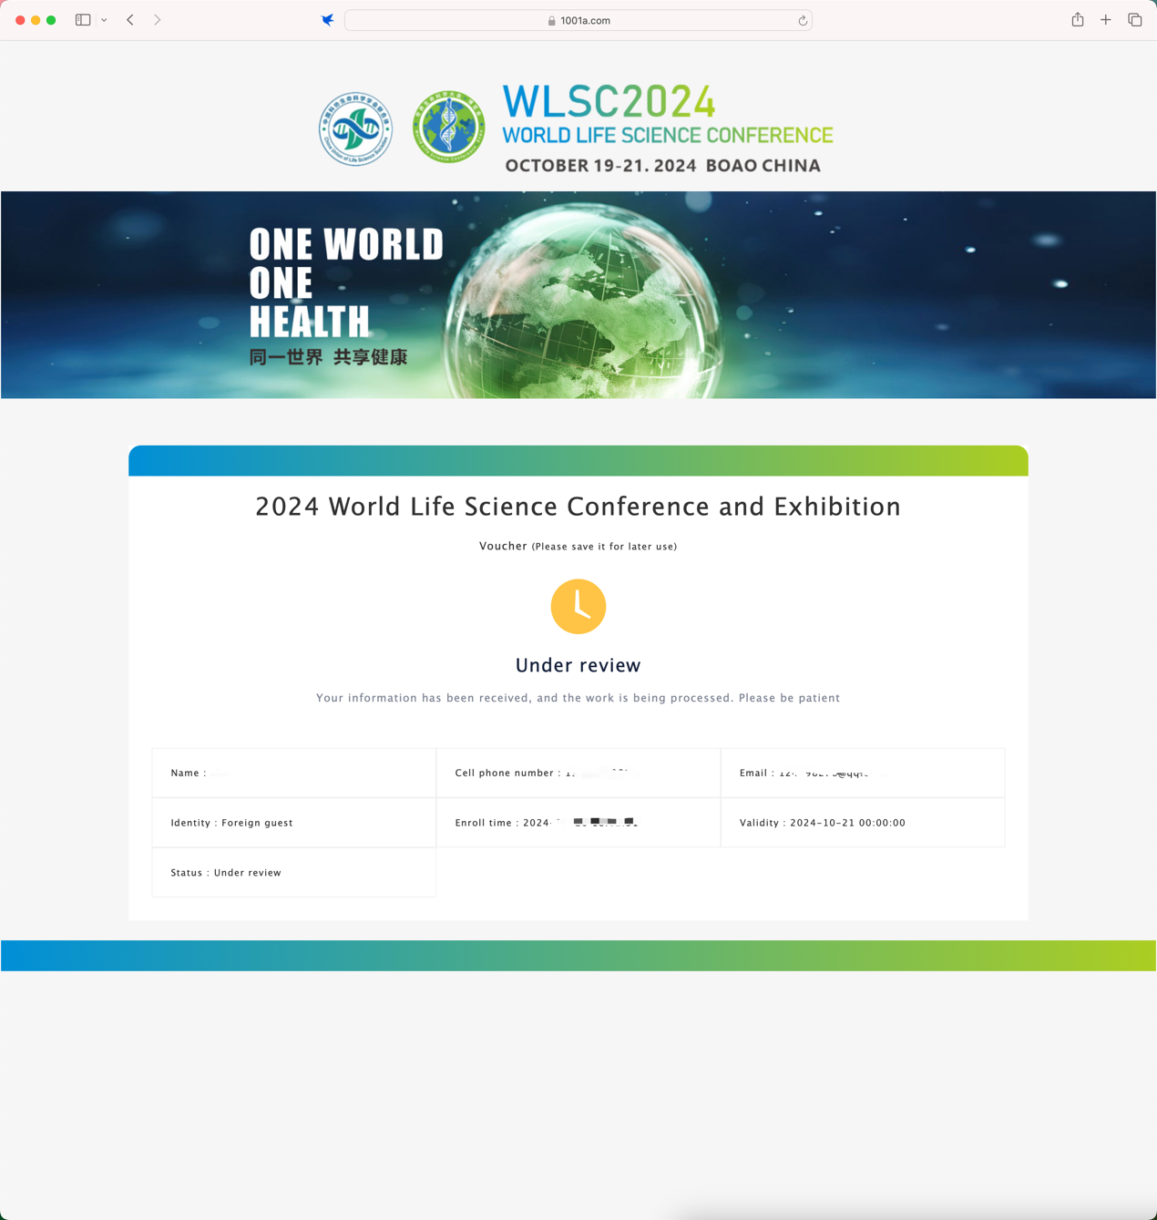

1. After the registration information is submitted, it will enter the review status. Subsequently, you can log in to this page to check the review status, and after the review is passed, you can view the QR code for participation.

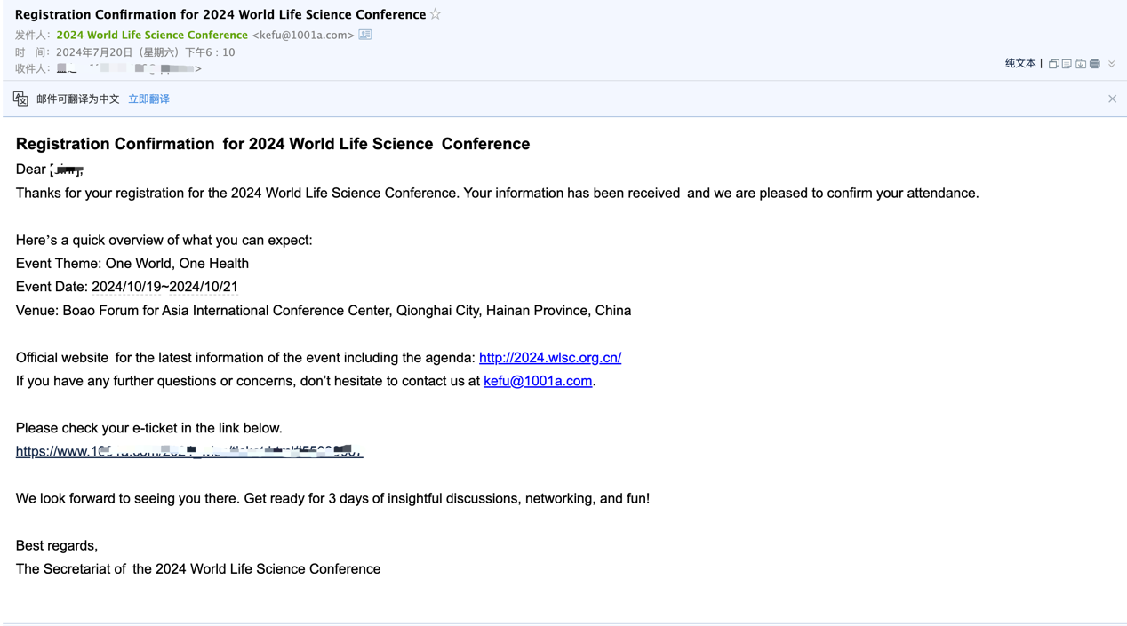

1. After the registration information is approved, you will receive a successful registration email, and you can view the QR code through the link in the email.